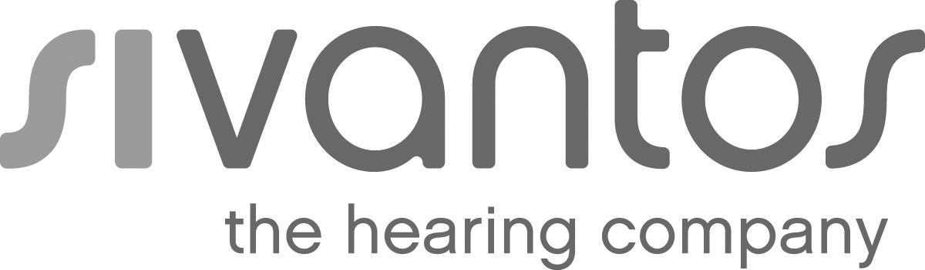 | Press
 | Singapore, October 17, 2018
Sivantos introduces new Signia in-the-ear hearing aids with Bluetooth connectivity

- Signia Insio Nx ITC and ITE devices combine discretion with direct streaming of TV audio, music and phone calls thanks to sophisticated miniaturization
- Especially developed antennas and Ultra HD e2e binaural link provide first-class stereo sound quality and a natural hearing experience

Audiology technology leader Sivantos today presents its first in-the-ear custom hearing aids with the natural hearing experience of the Signia Nx platform and Bluetooth connectivity. Compatible with StreamLine Mic and StreamLine TV, the almost invisible Insio Nx in-the-canal (ITC) and the discreet in-the-ear (ITE) hearing aids are made to connect to the wearer’s smartphone, TV, and other Bluetooth-enabled devices.

A sophisticated level of technological miniaturization was required to complement these high-performance custom devices with Bluetooth connectivity. The tiny antennas developed for this purpose and integrated in the faceplates not only solve this challenge, they also provide first-class stereo sound quality when streaming. Even phone calls can be heard in both ears.

Insio Nx hearing aids are equipped with Signia’s Ultra HD e2eTM binaural link, which enables the left and right hearing aids to exchange audio information continuously, delivering the most natural hearing experience. Wearers enjoy excellent speech understanding and the natural sound quality even in noisy situations.

For more information: www.signia-pro.com/insionx-bluetooth/

About the Sivantos Group
The business operations of the former Siemens AG hearing aid division have been combined into the Sivantos Group
since early 2015. Sivantos can look back on 140 years of German engineering and countless global innovations.
Today Sivantos is one of the leading hearing aid manufacturers worldwide. With its around 6,000 employees, the group
recorded revenues of 967 million euros in the fiscal year 2016/2017 and an adj. EBITDA of 238 million
euros. Sivantos' international sales organization supplies hearing care specialists and sales partners in more than 120
countries. Particularly high value is placed on product development. Sivantos aims to become the market leader in the
coming years with its brands Signia, Siemens, Audio Service, Rexton, A&M, HearUSA and audibene. The owners of
Sivantos are the anchor investors EQT along with the Strüngmann family as a co-investor.
Sivantos GmbH is a brand license holder of Siemens AG. More information can be found at www.sivantos.com

Contact for journalists:
Erika Weigmann
Phone: +49 9131 308 3449; E-Mail: erika.weigmann@sivantos.com

Press images
All photos are available for download at sivantos.com/category/press/

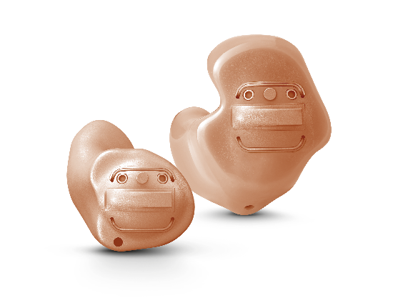

Signia Insio Nx ITC and ITE devices combine discretion with direct streaming of TV audio, music and phone calls.
Copyright: Sivantos

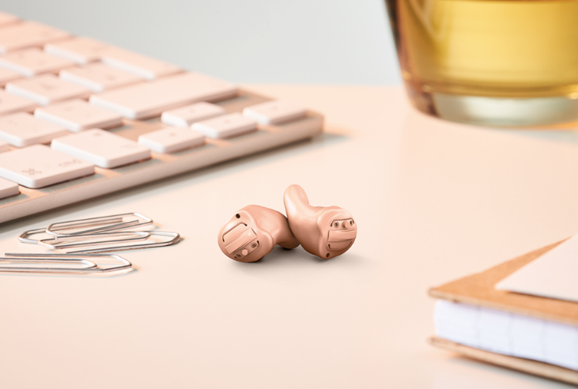

The almost invisible Insio Nx
in-the-canal (ITC) hearing aids are made to connect to the wearer’s smartphone, TV, and other Bluetooth-enabled devices.
Copyright: Sivantos

