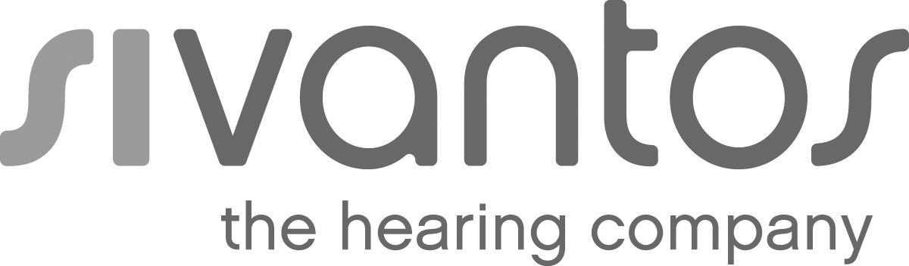 | Press
 | Singapore, October 17, 2018
Sivantos introduces wireless charging to its Signia Motion hearing aids

- New Signia MotionTM Charge&Go Nx combines inductive rechargeability, Own Voice Processing (OVP™), Bluetooth connectivity and TeleCare in one device
- High-capacity Li-ion power cell provides long-lasting high-quality stereo streaming plus contactless charging for intuitive handling

Audiology technology leader Sivantos today unveiled its latest Li-ion rechargeable hearing aids on the Signia NxTM hearing aid platform. Motion Charge&Go Nx offers wireless rechargeability and Bluetooth connectivity to wearers of behind-the-ear hearing aids with mild to severe hearing loss and the most varied fitting requirements.

Motion Charge&Go Nx hearing aids provide easy and intuitive handling thanks to wireless charging. Wearers no longer need to worry that they might struggle to change disposable batteries. They simply charge them up with power while they sleep by placing them into the wells of the small charger, so the hearing aids are ready to go whenever the wearer is ready.

Combining excellent sound with ease of use
The proven Signia Nx platform improves spontaneous acceptance by 80 percent¹ by replicating the natural sound of the wearer’s own voice via Own Voice Processing (OVP). OVP frees hearing care professionals from having to compromise on audibility to improve the sound of the own voice. It detects and processes the sound of the wearer’s voice completely independently from all surrounding sounds, including all other voices, for the most natural hearing experience with hearing aids.

In addition, the high-capacity Li-Ion power cell of Motion Charge&Go Nx supports continuous Bluetooth connectivity, allowing wearers to enjoy long-lasting high-quality stereo streaming of TV audio, music, and phone calls.

Full live remote tuning after the first fitting is supported via Signia TeleCare and the powerful Connexx fitting software. This provides the optimal tool to keep hearing aid trials on track and convert patients with hearing loss into satisfied customers.

For more information: www.signia-pro.com/motion-charge-go/

¹ 2017 “OVP Study” conducted at University of Northern Colorado examining the effect of Own Voice Processing on
spontaneous acceptance after first fit of hearing aids. Further details: www.signia-pro.com/ovp-study

About the Sivantos Group
The business operations of the former Siemens AG hearing aid division have been combined into the Sivantos Group
since early 2015. Sivantos can look back on 140 years of German engineering and countless global innovations.
Today Sivantos is one of the leading hearing aid manufacturers worldwide. With its around 6,000 employees, the group
recorded revenues of 967 million euros in the fiscal year 2016/2017 and an adj. EBITDA of 238 million
euros. Sivantos' international sales organization supplies hearing care specialists and sales partners in more than 120
countries. Particularly high value is placed on product development. Sivantos aims to become the market leader in the
coming years with its brands Signia, Siemens, Audio Service, Rexton, A&M, HearUSA and audibene. The owners of
Sivantos are the anchor investors EQT along with the Strüngmann family as a co-investor.
Sivantos GmbH is a brand license holder of Siemens AG. More information can be found at www.sivantos.com

Contact for journalists:
Erika Weigmann; Phone: +49 9131 308 3449; E-Mail: erika.weigmann@sivantos.com

Press images
All photos are available for download at sivantos.com/category/press/
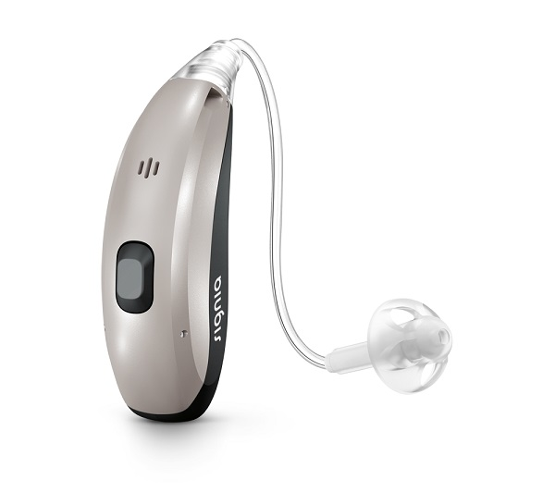

With its high-capacity Li-Ion power cell Motion Charge&Go Nx allows wearers to enjoy long-lasting high-quality stereo streaming of TV audio, music, and phone calls.
Copyright: Sivantos

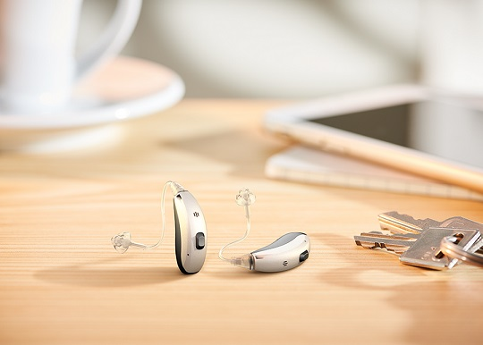

Motion Charge&Go Nx from the brand Signia offers inductive charging, Bluetooth connectivity, natural sound experience and remote fitting in one device.
Copyright: Sivantos

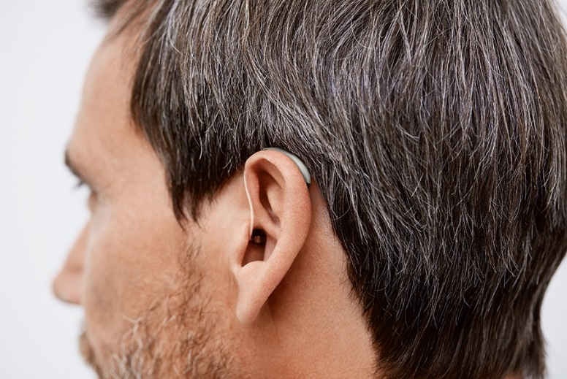

Motion Charge&Go Nx from the brand Signia combines inductive charging, Own Voice Processing, Bluetooth connectivity and TeleCare in one device.
Copyright: Sivantos

